Windows Autopilot Hardware Hash
Complete SOP for New Box-Pack Windows Laptops
Collect | Validate | Prepare CSV | Import to Intune | Assign Profile | Verify OOBE

Purpose
This SOP gives a first-time technician a complete, repeatable process starting from a sealed/new laptop at Windows OOBE, through hardware hash collection, CSV preparation, Windows Autopilot registration in Microsoft Intune, profile assignment, and final validation.

Document owner | Endpoint Management / IT Operations
Applies to | Windows 10/11 devices; Diagnostics export method requires Windows 11
Primary platform | Microsoft Intune and Windows Autopilot
Version | 1.0
Prepared date | 22 September 2026
Classification | Internal use

1. Concept and End-to-End Flow

1.1 What is a hardware hash?
A Windows Autopilot hardware hash is a device-specific hardware identity used to register a Windows device with the organization’s Autopilot service. The import record normally contains the device serial number, an optional Windows Product ID, the hardware hash, and optionally a Group Tag.
Important distinction
Ctrl + Shift + D opens the Windows Autopilot Diagnostics page in Windows 11 OOBE. Exporting logs from this page includes a CSV containing the hardware hash. Shift + F10 opens Command Prompt and is used for the PowerShell collection method. The diagnostics shortcut does not manually display the full hash for copying.

1.2 Process flow
- Receive and record laptop serial number
- Power on and stop at Windows OOBE
- Connect to internet and insert USB drive
- Collect hash by Method A or Method B
- Validate the generated CSV
- Import CSV into Windows Autopilot devices
- Sync and confirm device registration
- Assign Group Tag / dynamic group / deployment profile
- Wait for Profile status = Assigned
- Reset or restart OOBE and complete user enrollment

1.3 Required access and material
- USB drive with sufficient free space, preferably formatted as exFAT or NTFS.
- Internet connection for the PowerShell method and cloud import.
- Intune Administrator, Policy and Profile Manager, or an appropriate custom Autopilot role.
- Microsoft Intune subscription, automatic Windows enrollment, and required Microsoft Entra licensing/configuration.
- The correct Group Tag and deployment profile targeting design for the organization.

2. Method A: Windows 11 Diagnostics Export
Best used when
The new laptop is at Windows 11 OOBE and the Diagnostics page is available. This is the easiest visual method and does not require typing PowerShell commands.

2.1 Steps
- Unbox the laptop, connect the charger, and power on the device.
- Proceed only until the Windows OOBE screens appear. Do not create a personal account or complete consumer setup.
- Connect the laptop to a reliable network if requested.
- Insert the USB drive. Create a dedicated folder or HardwareHash to keep exports organized.
- Press Ctrl + Shift + D together. On some keyboards, the Fn key might also be required.
- On the Windows Autopilot diagnostics page, select Export logs.
- Select the USB drive and the required folder, then select Select Folder.
- Wait until Logs successfully exported appears. Do not remove the USB drive while export is running.
- Select Close and safely remove the USB drive.
- On another computer, open the exported device folder and locate the CSV file that contains the serial number and hardware hash.
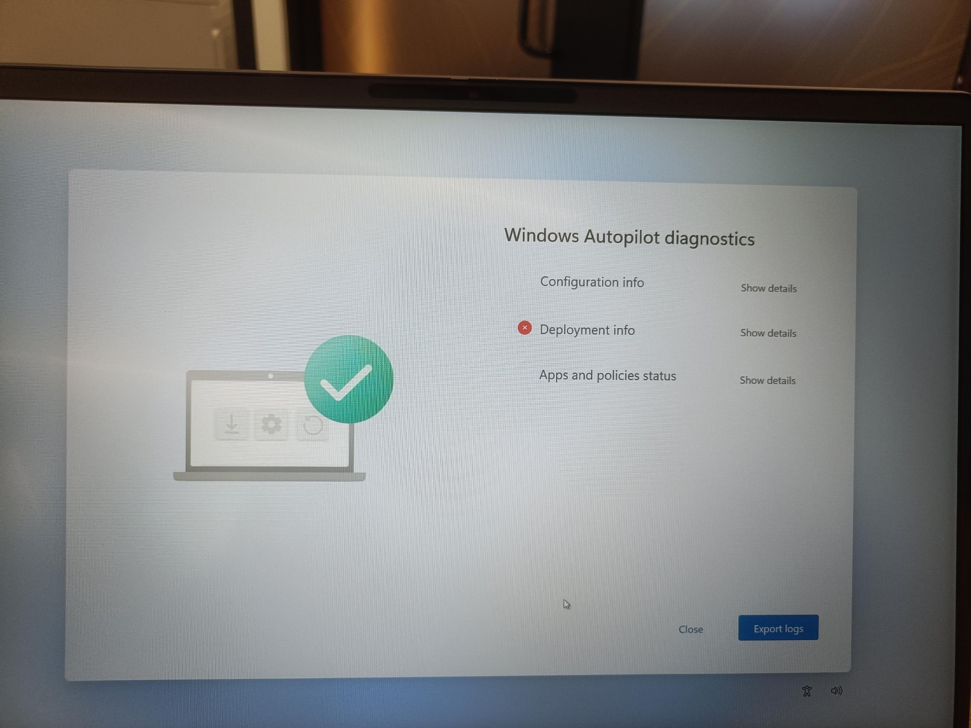
Figure 1. Windows Autopilot diagnostics page opened using Ctrl + Shift + D. Select Export logs.
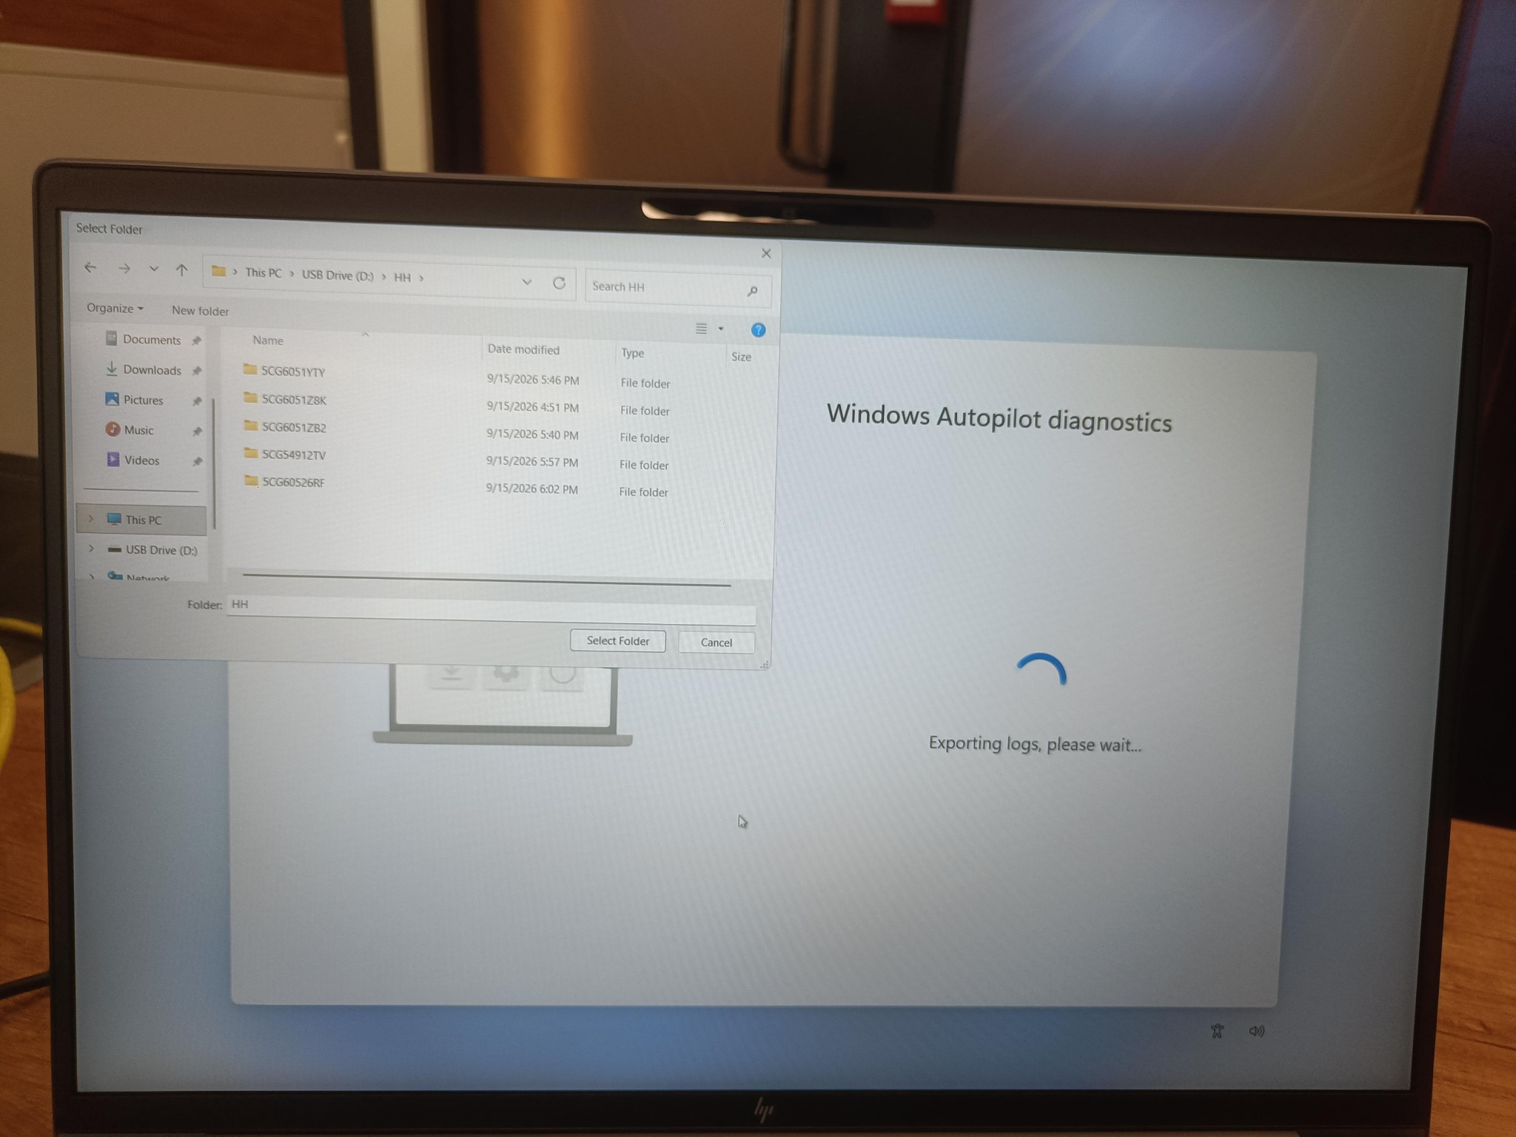
Figure 2. Select the USB drive as the export destination.

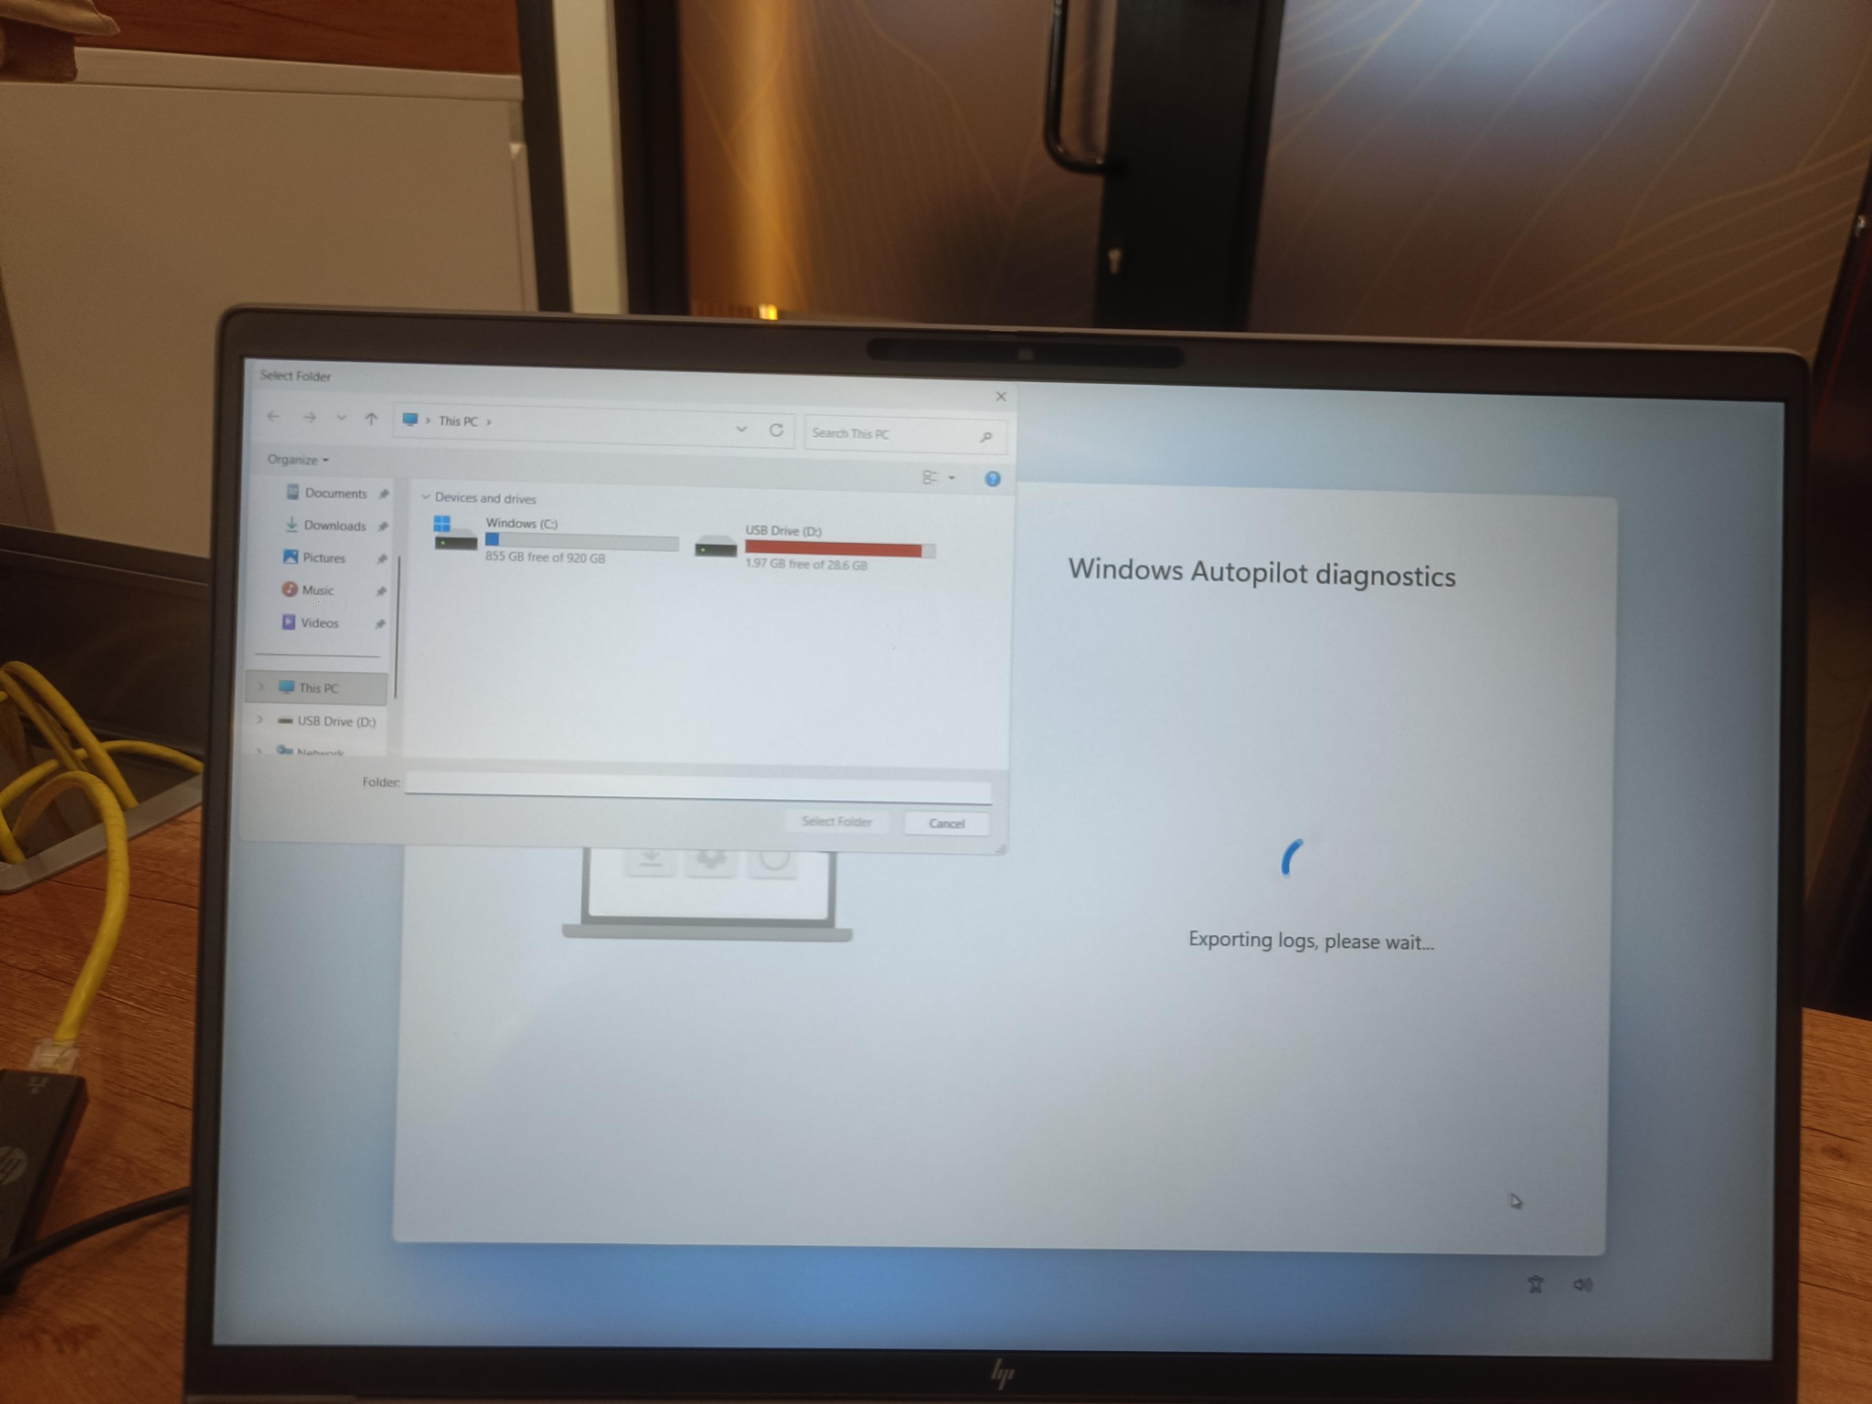
Figure 3. Select a dedicated folder, such as HH, to keep each device export organized.
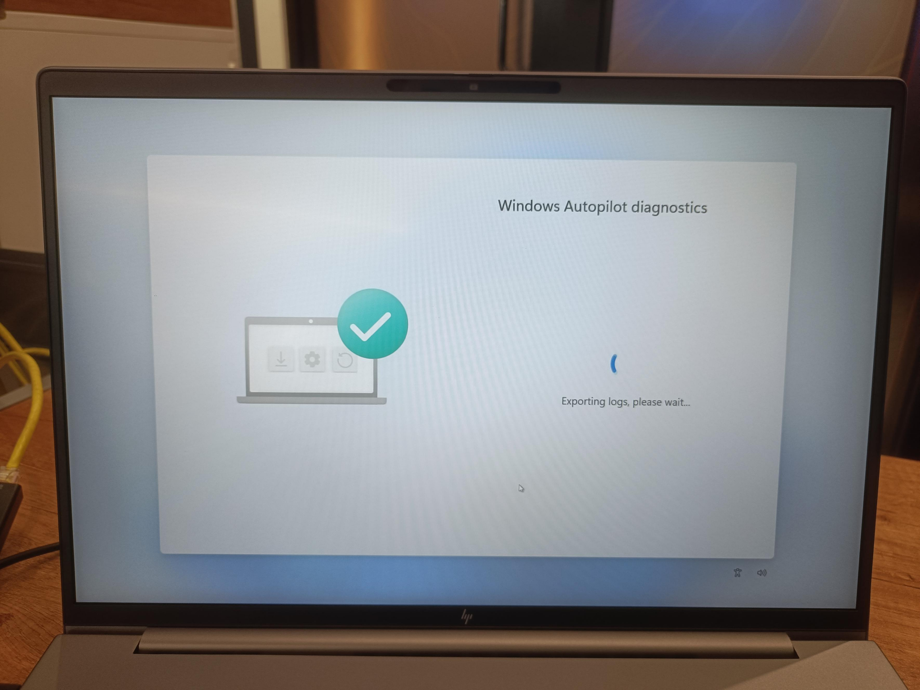
Figure 4. Export in progress. Keep the USB drive connected.
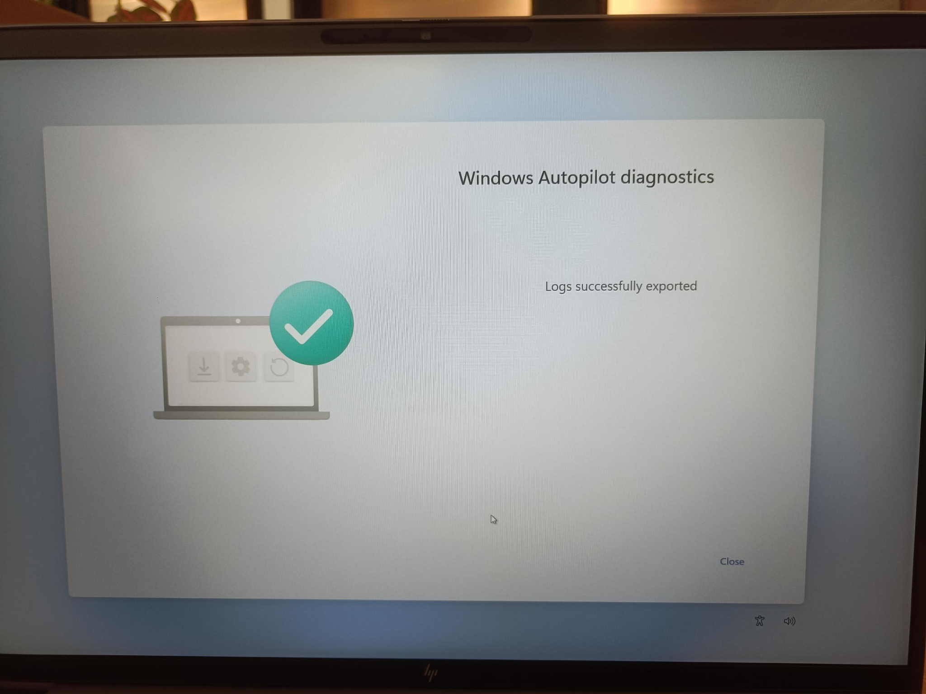
Figure 5. “Logs successfully exported” confirms the export has completed.
Output check
The exported logs contain a CSV with the hardware hash. Open the device-specific export folder and identify the CSV before proceeding. Keep the original exported folder as evidence and make a working copy of the CSV for import.

3. Method B: PowerShell from OOBE
Best used when
The Diagnostics page is unavailable, the laptop is Windows 10, or a direct, clean AutopilotHWID.csv file is required.

3.1 Open Command Prompt and PowerShell
- At the Windows OOBE screen, press Shift + F10. If the shortcut does not work, try Fn + Shift + F10.
- A Command Prompt window opens. Type powershell.exe and press Enter.
- Confirm that the prompt changes to a PowerShell prompt.
- The laptop must be connected to the internet so that the official script can be installed from PowerShell Gallery.
powershell.exe

3.2 Run the commands in order
[Net.ServicePointManager]::SecurityProtocol = [Net.SecurityProtocolType]::Tls12
New-Item -Type Directory -Path "C:\HWID" -Force
Set-Location -Path "C:\HWID"
$env:Path += ";C:\Program Files\WindowsPowerShell\Scripts"
Set-ExecutionPolicy -Scope Process -ExecutionPolicy RemoteSigned -Force
Install-Script -Name Get-WindowsAutopilotInfo -Force
Get-WindowsAutopilotInfo -OutputFile AutopilotHWID.csv

Expected file location:
C:\HWID\AutopilotHWID.csv

3.3 Copy the file to USB
If the USB drive letter is D:, use the following example. Confirm the actual drive letter before running the copy command.
Copy-Item "C:\HWID\AutopilotHWID.csv" "D:\AutopilotHWID_<SerialNumber>.csv"

Why RemoteSigned is used
The execution policy is changed only for the current PowerShell process. Closing PowerShell ends this temporary scope. There is normally no need to run a second execution-policy command to restore it.

4. Optional Collection Variations

4.1 Direct upload from OOBE
Use only when organizational policy allows the technician to sign in and grant the required Microsoft Graph permissions. This removes the manual CSV upload step.
[Net.ServicePointManager]::SecurityProtocol = [Net.SecurityProtocolType]::Tls12
Set-ExecutionPolicy -Scope Process -ExecutionPolicy RemoteSigned -Force
Install-Script -Name Get-WindowsAutopilotInfo -Force
Get-WindowsAutopilotInfo -Online

- Sign in when prompted using an authorized administrator account.
- Confirm the device import completes successfully.
- In Intune, open Windows Autopilot devices, select Sync, and verify the serial number.
Security note
The 4K hardware hash is sensitive device registration data. Store it only in approved IT locations. Do not send it through personal email or retain it on an unsecured USB drive.

4.2 If Install-Script fails
- Confirm internet access, date/time, DNS, and proxy/firewall access to PowerShell Gallery.
- Confirm PowerShell was opened from Shift + F10 and that the current prompt is PowerShell, not Command Prompt.
- If asked to install NuGet provider or trust PSGallery, enter Y.
- Run Get-PSRepository to confirm PSGallery is available.
- If the organization blocks online script installation, use a pre-approved offline copy of Get-WindowsAutopilotInfo.ps1 from a secured USB drive and run it from that location.
Get-PSRepository
Get-Help Get-WindowsAutopilotInfo -Full

5. CSV Format and Validation

5.1 Supported column structure
Device Serial Number | Windows Product ID | Hardware Hash | Group Tag
5CxxxxxxxC6 | Blank is acceptable | Long exported hash value | IDC

5.2 Example record from the attached sample
The attached sample uses this exact header order and includes Group Tag IDC:
Device Serial Number,Windows Product ID,Hardware Hash,Group Tag
5CxxxxxxxC6,,T0HaBAExxxxxxxxx...(full exported hash)...AAAAAAAAAAA,IDC

Do not manually shorten the hash
The hardware hash is a long value. Keep the complete exported value in one CSV cell. Do not add line breaks, spaces, smart quotes, formulas, or thousands separators. The Windows Product ID field may be empty.

5.3 Validation checklist before import
- File extension is .csv, not .xlsx or .txt.
- Header names and order match the supported Autopilot format.
- Each device is on one row.
- Serial number matches the physical device and export folder.
- Complete hardware hash is present and has not been wrapped across rows.
- Group Tag is correct for the deployment profile targeting design.
- No blank rows appear above the header.
- No extra commas were added inside a field.
- Keep the file at 500 devices or fewer per manual import batch.

6. Import the Device into Microsoft Intune

6.1 Portal navigation
- Sign in to the Microsoft Intune admin center.
- Go to Devices.
- Under By platform, select Windows.
- Under Device onboarding, select Enrollment.
- In the Windows Autopilot section, select Devices.
- In Windows Autopilot devices, select Import.
- Browse to the validated CSV file and start the import.
- Monitor Notifications until Devices imported is shown.
- Select Sync after import completes.
- Use the serial number search box to confirm that the device appears.
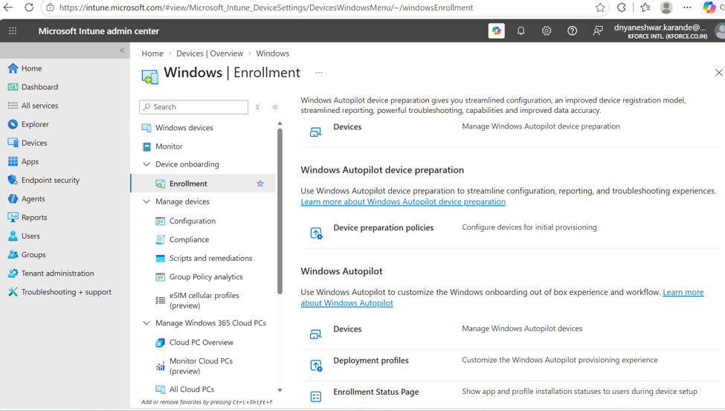
Figure 6. Windows Enrollment page. Under Windows Autopilot, select Devices to manage imported Autopilot identities.
Registration is not enrollment
CSV import registers the device identity with Windows Autopilot. The device becomes an Intune-managed device only when the user/device completes enrollment during OOBE or another enrollment process.

7. Group Tag, Profile Assignment, and Final OOBE

7.1 Confirm profile targeting
- Open the imported device record and confirm the correct serial number and Group Tag.
- Confirm the device becomes a member of the intended Microsoft Entra device group, if dynamic-group targeting is used.
- Open the Windows Autopilot deployment profile and confirm the correct group is included in Assignments.
- Return to Windows Autopilot devices and wait until Profile status shows Assigned.
- Do not hand over the laptop while the profile is unassigned.

7.2 Return the laptop to a clean OOBE state
- If only diagnostics logs were exported and setup was not completed, close the diagnostics page and restart OOBE after profile assignment.
- If Windows setup was completed or the device was used for testing, perform an approved wipe/reset before final handover.
- Connect to internet at OOBE and wait for the organization-branded sign-in experience.
- The assigned user signs in with the approved work account.
- Monitor Enrollment Status Page, application installation, configuration profiles, compliance, and security policy processing.

7.3 Final acceptance checklist
- Correct organization branding and sign-in screen are displayed.
- Device is visible under Windows Autopilot devices.
- Profile status is Assigned.
- Device appears in Intune Windows devices after enrollment.
- Primary user and ownership are correct.
- Required apps and security policies are applied.
- BitLocker recovery key is escrowed where required.
- Asset tracker is updated with serial number, user, date, model, and status.
- USB copy of the hardware hash is removed or securely archived according to policy.

8. Troubleshooting Quick Reference
Issue | Likely cause | Action
Ctrl + Shift + D does not open diagnostics | Unsupported build, not at suitable OOBE stage, or keyboard function-key behavior | Use Fn if required, or use Shift + F10 and Method B.
Shift + F10 does not open Command Prompt | Function keys mapped to media controls or OEM restriction | Try Fn + Shift + F10; verify keyboard and OOBE stage.
Install-Script is not recognized | PowerShell session/path issue | Run powershell.exe, ensure the Scripts path command was entered, and retry.
Unable to download script | No internet, proxy, TLS, DNS, or PSGallery blocked | Check network and run the TLS command. Use approved offline script if required.
CSV import fails | Incorrect headers, altered hash, extra commas, wrong encoding, duplicate registration | Use the generated CSV/template, validate one row, and check whether the device belongs to another tenant.
Device imported but not visible | Import/sync still processing | Check Notifications, select Sync, wait several minutes, and search by serial number.
Profile status remains unassigned | Group Tag, dynamic-group membership, or assignment mismatch | Confirm tag, group rule, profile assignment, and sync status.
Normal consumer OOBE appears | Profile not assigned or device has not contacted Autopilot service | Confirm Assigned status, connect to internet, and restart/reset OOBE.
Deployment info shows an error | App, policy, network, or enrollment-stage failure | Open diagnostics details, export logs, review failed item, and troubleshoot the specific deployment component.

9. Technician Record and Handover Checklist
Date
Technician
Asset ID
Manufacturer / Model
Serial Number
Collection method
CSV file name
Group Tag
Import result
Profile status
Assigned user
Remarks / ticket number

9.1 Naming convention recommendation
AutopilotHWID_<SerialNumber>.csv
Example: AutopilotHWID_5CxxxxxxxC6.csv

9.2 Folder structure recommendation
HardwareHash\
YYYY-MM-DD\
<SerialNumber>\
Original_Diagnostics_Export\
AutopilotHWID_<SerialNumber>.csv
Import_Result_or_Ticket.txt

10. Reference, Definitions, and Command Sheet

10.1 Quick command sheet
# Open PowerShell from Command Prompt
powershell.exe

# Create output folder and collect CSV
[Net.ServicePointManager]::SecurityProtocol = [Net.SecurityProtocolType]::Tls12
New-Item -Type Directory -Path "C:\HWID" -Force
Set-Location -Path "C:\HWID"
$env:Path += ";C:\Program Files\WindowsPowerShell\Scripts"
Set-ExecutionPolicy -Scope Process -ExecutionPolicy RemoteSigned -Force
Install-Script -Name Get-WindowsAutopilotInfo -Force
Get-WindowsAutopilotInfo -OutputFile AutopilotHWID.csv

10.2 Key definitions
- OOBE: Out-of-box experience shown when Windows starts for initial setup.
- Windows Autopilot registration: Cloud registration of the device identity for deployment behavior.
- Intune enrollment: The process that makes the device managed by Microsoft Intune.
- Group Tag: Optional CSV field used to categorize/target Autopilot devices.
- Deployment profile: Autopilot configuration controlling the user’s OOBE experience.
- Enrollment Status Page: Setup screen used to track required device and user configuration.

10.3 Official reference
Microsoft Learn: Manually register devices with Windows Autopilot
https://learn.microsoft.com/autopilot/add-devices
This SOP should be reviewed whenever Microsoft changes Intune navigation, Autopilot registration requirements, supported scripts, or permissions.
Files supplied with this SOP
1. Windows_Autopilot_Hardware_Hash_Complete_SOP.docx
2. Autopilot_Hardware_Hash_Import_Template.csv
The original attached Import example.csv can also be retained as a reference sample.

